### ArrayList

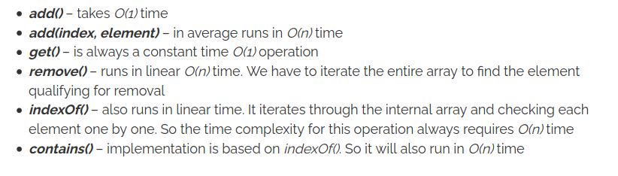

### CopyOnWriteArrayList

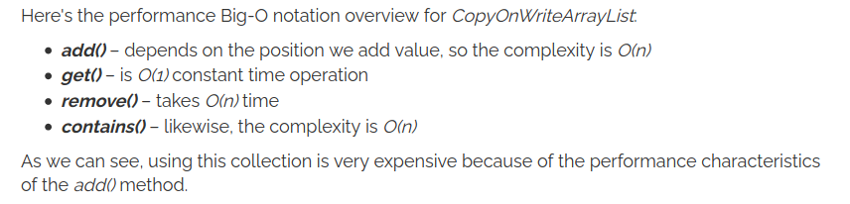

### LinkedList

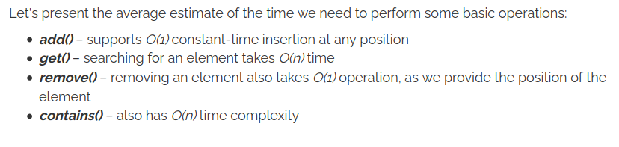

## Map

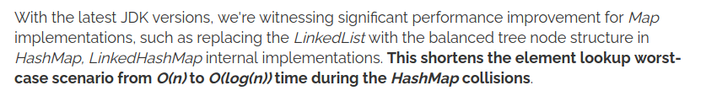

We can also learn, that storing and retrieving elements from the HashMap takes constant O(1) time.

We have O(1) for HashMap, LinkedHashMap, IdentityHashMap, WeakHashMap, EnumMap and ConcurrentHashMap for “containsKey”, “get”, “put”, “remove”.

For the tree structure TreeMap and ConcurrentSkipListMap the put(), get(), remove(), containsKey() operations time is O(log(n)).

## **Set**

For HashSet, LinkedHashSet, and EnumSet the add(), remove() and contains() operations cost constant O(1) time. Thanks to the internal HashMap implementation.

Likewise, the TreeSet has O(log(n)) time complexity for the operations like: add(), remove() and contains()

The time complexity for ConcurrentSkipListSet is also O(log(n)) time, as it is based in skip list data structure.